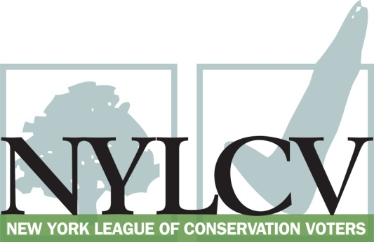

30 Broad Street – 30th Floor
New York, NY 10004
212-361-6350
politics@nylcv.org / www.nylcv.org
2018 Environmental Questionnaire
for New York State Candidates
Thank you for taking the time to fill out the New York League of Conservation Voters Questionnaire.
To ensure your responses address the issues NYLCV and its partners are most concerned about, please consult NYLCV’s 2018 New York State Policy Agenda when answering the questions.
The New York League of Conservation Voters is the only non-partisan statewide environmental organization in New York that fights for clean water, clean air, renewable energy and open space through political action. This questionnaire is designed to elicit your views regarding what environmental, public health, clean energy and transit and environmental justice groups consider to be the most important issues of the day. Responses may inform NYLCV’s educational and legislative programs and actions NYLCV takes in the election cycle.
Responses should be considered public. Although NYLCV may choose not to publicize responses to every question, verbatim responses may be reproduced and distributed publicly. If so, your responses may be shortened, if necessary, but will not be edited in substantive ways. If you choose to refer us to a position paper or website, please indicate exactly what text you would like us to cite. For candidates choosing not to respond to the questionnaire, NYLCV will note as much in its public materials.
NYLCV and its partners in the environmental policy arena believe that New York’s voters are determined to make the environment a voting issue this year. Candidate positions on issues such as protecting public health, building a clean energy future, and mitigating climate change will help voters decide how to cast their ballots this election cycle. This questionnaire is one of the primary ways the public will get this information.
Here are a few guidelines:
- Questionnaires are due Friday, May 25, 2018
- The completed questionnaire is mandatory for endorsement consideration and must be submitted via e-mail as a Microsoft Word file to: politics@nylcv.org
- Questions or extension requests may be directed to Joshua Klainberg (jklainberg@nylcv.org)
- After receipt of the completed questionnaire, candidates will be invited to participate in a formal interview with a local Chapter Board.
- All candidate endorsements will be made by the NYLCV State Board on July 25, 2018
Campaign Contact Information
Candidate name:
Office sought & district number (if applicable):
Campaign e-mail:
Campaign phone:
Website:
Facebook page:
Twitter handle:
Campaign manager’s name and email:
Press Secretary’s name and email:
Scheduler’s name and email:
PERSONAL INFORMATION
- Please share your accomplishments or experiences that indicate your commitment to advancing a pro-environment agenda. These experiences may be professional or personal.

ISSUES
Each year, NYLCV works closely with New York’s leading environmental, public health, conservation, energy, environmental justice, and transportation organizations to identify the state’s most pressing priorities on fighting climate change, conserving land and water, and protecting public health. These issues drive NYLCV’s advocacy work throughout the legislative session and also influences the bills we select for NYLCV’s State Environmental Scorecard as well as the candidates we choose to endorse.

Please indicate your level of commitment to, and if applicable your recent personal and professional activity, with respect to all the policy priorities of our partners per the following issues:

(To ensure your responses address the issues NYLCV and its partners are most concerned about, please review NYLCV’s 2018 New York State Policy Agenda when formulating your responses.)

Top Priorities

- Food Waste (p. 1)
- Congestion Pricing and Funding Mass Transit (p. 1)
- Reduce Single-Use Bags (p. 1)
- Protect Children from Toxic Chemicals (p. 1)

- Ensure Adequate Funding for the Environment (p. 2)

Address Causes and Effects of Climate Change

- Clean Energy for All (p. 3)

- Meet Renewable Energy Goals (p. 3)

- Transportation Infrastructure and Efficiency (p. 3)

- Resiliency (p. 4)

- Sustainable Development (p. 4)
Protect the Health of New Yorkers and Their Communities
- Toxics (p. 5)
- Air Quality (p. 5)
- Food Quality and Security (p. 5)

- Conserve Natural Resources (p. 6)

