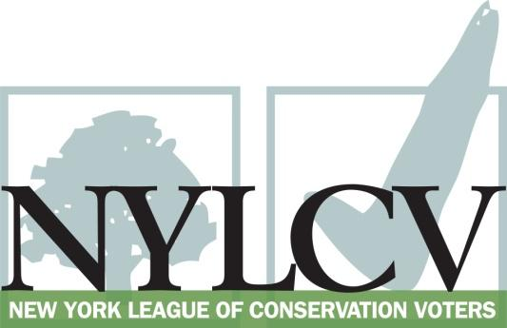

30 Broad Street – 30th Floor
New York, NY 10004
212-361-6350
politics@nylcv.org
www.nylcv.org
2017 Environmental Candidate Questionnaire
for Westchester Candidates
Thank you for taking the time to fill out the New York League of Conservation Voters Questionnaire.
The New York League of Conservation Voters is the only non-partisan statewide environmental organization in New York that fights for clean water, clean air, renewable energy and open space through political action. This questionnaire is designed to elicit your views regarding what environmental, public health, clean energy and transit and environmental justice groups consider to be the most important issues of the day. Responses may inform NYLCV’s educational and legislative programs and actions NYLCV takes in the election cycle.
Responses should be considered public. Although NYLCV may choose not to publicize responses to every question, verbatim responses may be reproduced and distributed publicly. If so, your responses may be shortened, if necessary, but will not be edited in substantive ways. If you choose to refer us to a position paper or website, please indicate exactly what text you would like us to cite. For candidates choosing not to respond to the questionnaire, NYLCV will note as much in its public materials.
NYLCV and its partners in the environmental policy arena believe that New York’s voters are determined to make the environment a voting issue this year. Candidate positions on issues such as protecting public health, building a clean energy future, and mitigating climate change will help voters decide how to cast their ballots this election cycle. This questionnaire is one of the primary ways the public will get this information.
After receipt of your completed questionnaire, you will be invited to participate in a formal interview with our Chapter Board. The interview will provide you with an opportunity to present your credentials, elaborate on your questionnaire responses, and respond to questions. Here are a few more guidelines:
- Questionnaires are due Friday, June 2
- The completed questionnaire is mandatory for endorsement consideration and must be submitted via e-mail as a Microsoft Word file to: politics@nylcv.org
- To ensure your responses address the issues NYLCV and its partners are most concerned about, please review NYLCV’s 2016-17 Westchester Policy Agenda
- Questions or extension requests may be directed to Joshua Klainberg (jklainberg@nylcv.org)

Campaign Contact Information
Candidate Name: Warren J. Lucas
Office Sought (district if applicable): Supervisor
E-mail: wjlucas@optonline.net
Mailing Address: 68 Titicus Road, North Salem, NY 10560
Phone: 914 261 2636
Website:
Facebook Page: NorthSalemNYInfo
Twitter handle:
Campaign Manager’s name and email:
Press Secretary’s name and email:
Scheduler’s name and email:
PERSONAL INFORMATION
- Please share your accomplishments or experiences that indicate your commitment to advancing a pro-environment agenda. These experiences may be professional or personal.
I have been on the Town board for 28 years. I have been Supervisor since March 2009. Here are a few of my recent accomplishments.
I signed North Salem to Single Stream refuse pickup in 2014. We just won Westchester's award for the highest recycling community in Westchester County with 34% of refuse recycled.
Committed the Town to Community Choice Aggregation (CCA) program with renewable electrical. The default plan for all residences in the Town, including my own, is 100% renewable wind energy from CONSTELLATION ENERGY.
Passed Unified Solar permit legislation in April of 2017 allowing for solar energy with just a building permit, no planning board or site plan approvals required.
Support of Agricultural Districts in Westchester County. Just re upped the Town for 10 more year of Agricultural tax reductions. The Town has thousands of acres of Ag. use and Open Land including a biotic corridor for the protection of animal habitat.
Paced legislation to allows PACE Financing in North Salem. We are a member of EnergizeNY (I am on Board of Directors) offering PACE financing in our Town for support of energy efficient buildings.
Helped form the Local Development Corporation called the East of Hudson Watershed Corporation for dealing with high phosphorus loading in our local lakes and streams. Our goal is to reduce Phosphorus from entering into our water bodies to reduce algae and seaweed. I am on the Board of Directors and Treasurer of the Corporation. My Town has exceeded its DEC assigned phosphorus mitigation by 200%.
I am currently in a lawsuit with the Hudson River Clearwater Sloop LLC (Manna Joe Greene/Seth Davis with be a reference) against Constellation Energy, the PSC and Entergy. My goal is to further renewable energy by removing the ZEC charges for those who are paying for RECs. Next court date June 5th. I am the only Town in the State supporting Clearwater Sloop.
To protect the waters of Peach Lake and stop eutrophication because of SEPTIC issue built a $31M sewer plant. Four hundred and eighty four septics tanks were removed. The lake is in better shape than any other time in the past 50 years. The plant was built in 2011 and 2012 and turned on in 2013.
Received $800K grant to install CONECH Jellyfish in the Peach Lake Stormwater Basin to remove phosphorus from the drainage and streams enter peach lake. The work is completed this spring 2017.
Our Building Inspectors are being certified for Clean Energy Community certification. Work to be completed in a month.
The Town is in process to become a Clean Energy Community by June 30th 2017. Currently we have; CCA, PACE FINANCING, UNIFIED SOLAR completed. We are working on two others; Building Inspector Energy Building Certification and installation LED lighting on all streetlights in the Croton Falls Hamlet.

To enhance BIMODAL transportation to our MTA train station in the Hamlet of Purdys I applied for and received a $512,000 TAP grant for building pedestrian access to the station. I have also signed a Document of Understanding with the MTA and DOT to building and infrastructure to allow pedestrian access to the train station.
I formed the I684/I84 Consortium as a group to lobby NYMTC or transportation changes to minimize the traffic in our local towns which ruin our quality of life. We have had a great affect on DOT REGION 8 as per Tom Weiner Head Engineer for Region 8. We have lobbied for changes in our transportation spending to reduce the traffic problems in the towns of Bedford, Lewisboro, Somers, North Salem and Southeast who are members of the consortium. The Consortium also supported changes across neighboring Towns and passed legislation in each Town putting together a regional plan the DOT accepted. We regularly attend NYMTC meetings and are affectionately known by the Council as the I684/84 Consortium.
As the 2016-2017 President of the Westchester Municipal Officials Association WMOA, and as President of the Westchester Putnam Association of Town Supervisors WPATS, I supported the Hudson River Towns with "Ban the Barges". Writing letter of support and attending multiple meetings. The Coast Guard was allowing the oil industry to place oil laden barges along the Hudson Towns. I have included a copy of the letter.
As President of WPATS passed a resolution of all Town Supervisors supporting a cleanup of PCB's in the Hudson. The statement I made for the press in support of Hudson River Clearwater Sloop LLC, Manna Jo Greene was "The Hudson River is part of our heritage, from the earliest days of the Van Cortlandt Manor, and it continues to define our future today with the revitalization of our Hudson River Towns and their waterfronts. It is critically important that the job of cleaning the still PCB contaminated areas of the Hudson River be completed by General Electric. The economy of this region relies on a vibrant Hudson River. Supervisor Warren Lucas, Town of North Salem, President of the WPATS, the Westchester Putnam Association of Town Supervisors.
"

ISSUES
Please indicate your level of commitment to, and if applicable your recent personal and professional activity with respect to, the following issues:

(To ensure your responses address the issues NYLCV and its partners are most concerned about, please review NYLCV’s 2016-17 Westchester Policy Agenda)
- Sustainable Development: Advancing modernized zoning to encourage mixed land use and compact development
Support of large open spaces. Agricultural Districts supported allowing real estate tax reductions which supports open space protection. Enhancing hamlets with LED lighting. Building pedestrian access (cost $2M) to train stations in our Town.

- Invasive Species: Educating the public on this problem and implementing better management practices
Supporting my Conservation Advisory Councils invasive species legislation. On April 19th we have had a meeting to discuss the Conservation Advisory Council's Proposal for the Removal of Invasive Species in the Wetlands. The proposal will become law this year.

I have been working with the North Salem Open Land foundation on individual projects to remove invasive vines and barberry from open land parcels. I personally carry a folding saw in my car and have removed hundreds of strangler vines (Oriental Bittersweet) from trees on Town properties.

- Cleaner Air: Speeding up conversions and retrofits of home heating oil No. 6 and No. 4 to more efficient heating systems
There is no #4 or #6 oil used in Town. We have converted a number of buildings from #2 oil to Propane and Natural Gas and have converted furnaces to higher efficiency units. I worked with NYSE&G to get N.G. pipes into Town.

- Expanding Electric Vehicle (EV) Infrastructure: Facilitating the development of a larger network of charging stations that will encourage more municipalities, businesses and individuals to switch to EVs in the coming years
I have done nothing yet. We are working on this with NYSERDA. I want to add charging stations in my Town's MTA parking lots.

- Sustainable Public Access Management: Making significant impacts on energy use and the environment simply by deciding to spend money and deploy resources wisely
We have been using closed cell foam insulation in our building retrofits and just finished 'foaming' an older building, built in the 1860's reducing it energy requirements by over 50%.
In 2015 we finished a new highway garage that is using half the energy with a building double the size. In 2014 we turned out old building into a police, and court building. it used less than 50% of the energy used by the building previously.

- Transportation: Maximizing environmentally friendly mobility options in and around residential and commercial centers
Working with MTA and DOT on a project to provide pedestrian access to our train station in the Purdys Hamlet. I was told the $512K TAP grant was the best grant application the DOT recommended in 2017. The overall project will have different sections done by North Salem, the DOT and the MTA. Total cost is about $2M.

- Sustainable & Transit-Oriented Development: Creating livable and sustainable communities that permit increased density and diversity in our downtowns and neighborhoods
Not really. Our density is as high as currently possible. We are looking for money ($5M) for a sewer system in Croton Falls to allow for higher density in that Hamlet.

- Open Space Preservation: Planning strategies such as clustering, creating pocket parks in developed areas, and encouraging biotic corridors in less densely populated areas
Yes, very involved with Open space zoning and agricultural districts. Our biotic corridor, from Lewisboro through North Salem has been in place for some time. While I was not the Supervisor at the time I was on the Town Board and supported the purchased on additional lands of Purdy's Ridge an environmental sensitive area.
https://www.nsolf.org/index.php/what-we-protect/preserves
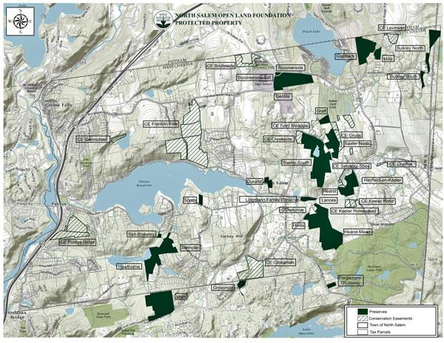
Regarding clustering, our zoning ordinance which we made changes to last year requires it.

- Natural Resource Protection: Comprehensively managing and protecting regional natural resources (i.e., air, water and land)
Yes it is throughout our zoning for many years. We limit development on steep slopes and are working on special MS4 stormwater legislation for smaller lots around Peach Lake that fall through the States MS4 regulations (under 5000 sq foot disturbance)

- Energy: Achieving energy efficiency in residential and commercial settings, in existing and new buildings, and with cutting-edge technology and the smarter use of older technology
Yes just passed the unified Solar permit. We now allow unlimited KWH generation from Solar on ones roof and up to 1000 square feet on the ground as of right. We are also involved with Municipal Solar through Sustainable Westchester and looking at placing solar on our Town garage and sewer district buildings.

- Farms and Local Food: Managing development and providing access to healthy, fresh foods
Yes, North Salem has not agricultural land than any other own in Westchester County. http://planning.westchestergov.com/images/stories/AgriculturalFarmBd/pdfsAgFarmBd/WCAgDist16Map.pdf North Salem circled in RED. I have 28 years of support.