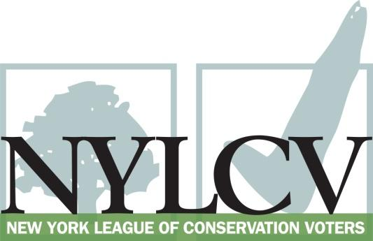

30 Broad Street – 30th Floor
New York, NY 10004
212-361-6350
politics@nylcv.org
www.nylcv.org
2017 Environmental Candidate Questionnaire
for Capital Region Candidates
Thank you for taking the time to fill out the New York League of Conservation Voters Questionnaire.
The New York League of Conservation Voters is the only non-partisan statewide environmental organization in New York that fights for clean water, clean air, renewable energy and open space through political action. This questionnaire is designed to elicit your views regarding what environmental, public health, clean energy and transit and environmental justice groups consider to be the most important issues of the day. Responses may inform NYLCV’s educational and legislative programs and actions NYLCV takes in the election cycle.
Responses should be considered public. Although NYLCV may choose not to publicize responses to every question, verbatim responses may be reproduced and distributed publicly. If so, your responses may be shortened, if necessary, but will not be edited in substantive ways. If you choose to refer us to a position paper or website, please indicate exactly what text you would like us to cite. For candidates choosing not to respond to the questionnaire, NYLCV will note as much in its public materials.
NYLCV and its partners in the environmental policy arena believe that New York’s voters are determined to make the environment a voting issue this year. Candidate positions on issues such as protecting public health, building a clean energy future, and mitigating climate change will help voters decide how to cast their ballots this election cycle. This questionnaire is one of the primary ways the public will get this information.
After receipt of your completed questionnaire, you will be invited to participate in a formal interview with our Chapter Board. The interview will provide you with an opportunity to present your credentials, elaborate on your questionnaire responses, and respond to questions. Here are a few more guidelines:
- Questionnaires are due Friday, June 9
- The completed questionnaire is mandatory for endorsement consideration and must be submitted via e-mail as a Microsoft Word file to: politics@nylcv.org
- To ensure your responses address the issues NYLCV and its partners are most concerned about, please review NYLCV’s 2016-17 Capital Region Policy Agenda
- Questions or extension requests may be directed to Joshua Klainberg (jklainberg@nylcv.org)

Campaign Contact Information
Candidate Name: Dorcey L. Applyrs
Office Sought (district if applicable): City of Albany Common Council
E-mail: dorceyapplyrs@gmail.com
Mailing Address: 6 South Marshall Street, Albany, NY 12209
Phone: 518-894-8981
Website: http://www.dorceyapplyrs.com/
Facebook Page: https://www.facebook.com/DorceyApplyrs4AlbanyCommonCouncil/
Twitter handle:
Campaign Manager’s name and email: Tina Vasquez: Tvasquez1088@gmail.com
Press Secretary’s name and email: N/A
Scheduler’s name and email: N/A
PERSONAL INFORMATION
- Please share your accomplishments or experiences that indicate your commitment to advancing a pro-environment agenda. These experiences may be professional or personal.
Since being elected to the Albany Common Council four years ago, a substantial amount of my time, energy and resources have been devoted to the needs of my residents who live near the Port of Albany and feel unable to defend themselves from environmental injustices. I took a lead role in raising awareness to the environmental, health and safety implications of oil transport in the City of Albany. This work has resulted in community organizing, national awareness, oversight from Governor Cuomo and his administration, a $500,00 comprehensive air quality study (currently being conducted by NYSDEC) and a traffic study being conducted near the Ezra Prentice Homes on Albany’s South End.
During my first year, I introduced legislation creating tobacco free parks in the City of Albany.
I spearheaded the Second Avenue Revitalization project to improve the built environment in low-income section of the First Ward. This initiative has resulted in increased code enforcement, improved sidewalks, home repairs and resident education. For the past two summers, I have facilitated a walk-thru for the City’s commissioners responsible for code enforcement and general services.

ISSUES
Please indicate your level of commitment to, and if applicable your recent personal and professional activity with respect to, the following issues:

(To ensure your responses address the issues NYLCV and its partners are most concerned about, please review NYLCV’s 2016-17 Capital Region Policy Agenda)

- Regional Transit Analysis: Working with the Capital Region Regional Economic Development Council to develop rapid transit options (i.e., bus and light rail) between central business districts
Very committed

- Renewable Energy: Streamlining and modernizing the process for obtaining government approval to install renewable energy facilities
Very committed

- Clean and Safe Water: Working to ensure counties and localities regularly test their drinking water using EPA’s Contaminant Candidate List and Unregulated Drinking Water Contaminants
Very committed- As a result of a community meeting I hosted, the City of Albany tested the drinking water for residents who raised concerns.

- Sustainable & Transit-Oriented Development: Creating livable and sustainable communities that permit increased density and diversity in our downtowns and neighborhoods
Very committed- I was a strong advocate for the inclusionary affordable housing requirement in the City of Albany’s rezone legislation that passed in May 2017.
I supported the rezone legislation because of its aim to create livable and sustainable communities in our downtowns and neighborhoods.

- Transportation: Maximizing environmentally friendly mobility options in and around residential and commercial centers
Very committed

- Open Space Preservation: Planning strategies such as clustering, creating pocket parks in developed areas, and encouraging biotic corridors in less densely populated areas
Very committed

- Sustainable Public Access Management: Making significant impacts on energy use and the environment simply by deciding to spend money and deploy resources wisely
Very committed

- Natural Resource Protection – Comprehensively managing and protecting regional natural resources (i.e., air, water and land)
Very committed

- Farms and Local Food: Managing development and providing access to healthy, fresh foods
Very committed- I have worked to support non-profits in the City of Albany who ensure residents, in particular low-income, have access to healthy food. This support includes grant writing and providing letters of support.
I introduced the Healthy Meetings and Events Law, requiring the City of Albany to adopt healthy meeting guidelines. The guidelines require healthy food options be offered at all meetings and events hosting by the City.

- Energy: Achieving energy efficiency in residential and commercial settings, in existing and new buildings, and with cutting-edge technology and the smarter use of older technology
Very committed

