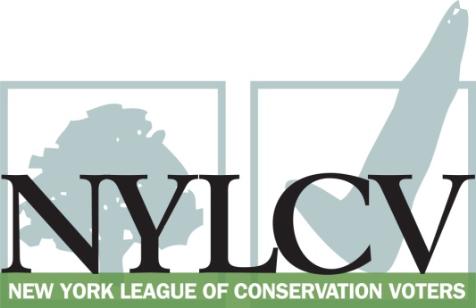

30 Broad Street – 30th Floor
New York, NY 10004
212-361-6350
politics@nylcv.org / www.nylcv.org
2017 Environmental Candidate Questionnaire
for New York City Candidates
Thank you for taking the time to fill out the New York League of Conservation Voters Questionnaire.
The New York League of Conservation Voters is the only non-partisan statewide environmental organization in New York that fights for clean water, clean air, renewable energy and open space through political action. This questionnaire is designed to elicit your views regarding what environmental, public health, clean energy and transit and environmental justice groups consider to be the most important issues of the day. Responses may inform NYLCV’s educational and legislative programs and actions NYLCV takes in the election cycle.
Responses should be considered public. Although NYLCV may choose not to publicize responses to every question, verbatim responses may be reproduced and distributed publicly. If so, your responses may be shortened, if necessary, but will not be edited in substantive ways. If you choose to refer us to a position paper or website, please indicate exactly what text you would like us to cite. For candidates choosing not to respond to the questionnaire, NYLCV will note as much in its public materials.
NYLCV and its partners in the environmental policy arena believe that New York’s voters are determined to make the environment a voting issue this year. Candidate positions on issues such as protecting public health, building a clean energy future, and mitigating climate change will help voters decide how to cast their ballots this election cycle. This questionnaire is one of the primary ways the public will get this information.
Here are a few guidelines:
- Questionnaires are due Friday, May 19
  - The completed questionnaire is mandatory for endorsement consideration and must be submitted via e-mail as a Microsoft Word file to: politics@nylcv.org
  - Questions or extension requests may be directed to Joshua Klainberg (jklainberg@nylcv.org)
- To ensure your responses address the issues NYLCV and its partners are most concerned about, please review NYLCV’s 2014-18 NYC Policy Agenda
- After receipt of the completed questionnaire, candidates will be invited to participate in a formal interview with our Chapter Board
- All candidate endorsements will be made by the state board on July 26, 2017
Campaign Contact Information
Candidate Name: Andrew Cohen
Office Sought (district if applicable): 11th NYC Council District
E-mail: AndyJCohen95@gmail.com
Mailing Address: 314 West 231st Street, #444, Bronx, NY 10463
Phone: 212-989-8434
Website:
Facebook Page: Re-Elect Council Member Andrew Cohen
Twitter handle: AndrewCohenNYC
Campaign Manager’s name and email: Dan Johnson, DJohnson687@gmail.com
Press Secretary’s name and email: Dan Johnson
Scheduler’s name and email: Dan Johnson
PERSONAL INFORMATION
- Please share your accomplishments or experiences that indicate your commitment to advancing a pro-environment agenda. These experiences may be professional or personal.
First, I have received a 100% rating from the League on the Environmental Score Card in 2015 and 2016. Second, through my participation on the Parks Committee along with the allocation of discretionary capital, I have worked hard to enhance green space both in my district and Citywide.

ISSUES
Please indicate your level of commitment to, and if applicable your recent personal and professional activity with respect to, the following issues:

(To ensure your responses address the issues NYLCV and its partners are most concerned about, please review NYLCV’s 2014-18 NYC Policy Agenda when formulating your responses.)
Healthy New Yorkers: Policies that improve the well-being of all New Yorkers through the protection of the environment and that provide access to basic needs.
- Water Quality — Every New Yorker has the right to clean drinking water and waterways
I support the policy agenda.

I am currently working on a project to day light Tibbet’s brook. In addition to restoring wetlands this project will ultimately redirect water out of New York City sewers and help reduce the occurrence of CSO in the Harlem River.

- Air Quality – Every New Yorker has the right to breathe clean air
I support the policy agenda. The City Council has taken numerous steps to improve both indoor and outdoor air quality.

- Healthy & Local Food – Every New Yorker has the right to access healthy, local, affordable produce
I support the agenda. In addition, I support universal free lunch, Green Markets and allocate food pantry money to make healthy nutritious food available.

- Green Buildings – Every New Yorker deserves the protection of a home that is energy efficient and is resilient to impacts of storms heat waves and extended utility outages
I support the agenda. We need to do more as New York City building are now the number one contributor to air pollution.

Strong Neighborhoods: Promote policies that improve the quality of life for communities in all five boroughs.

- Parks & Recreation – Every New Yorker should live within a 10-minute walk of a park that is clean, safe and well-maintained
I support the agenda and have a proven track record on my commitment to parks.

- Waterfront Access – Every New Yorker should have safe and public access to clean rivers, creeks, bays, harbors and other waterways
I support the agenda and have been a strong supporter of the Bronx River Alliance and have been an ardent supporter of connecting the Bronx to the Hudson River Greenway.
- Transportation – Every New Yorker should have safe, affordable, reliable and efficient transportation options in their daily life
I do support the agenda but much more needs to be done on this front. I am working on the creation of the first protected bike lane in my Council District.

Resiliency & Recovery – All communities should be better able to handle extreme weather events: rainfall, snow, storm surges, heavy wind, heat and utility failures
I do support the agenda. I am looking forward to a joint meeting of the Parks and Resiliency Committee being planned for this fall.

Vibrant Economy: Promote policies that foster green job creation while protecting New Yorkers from the effects of climate change

- Infrastructure – Make critical investments to maintain New York City’s competitive edge in the global economy while creating local jobs
I support the agenda and the specific projects in your agenda.

- Solid Waste – Effective solid waste management will reduce environmental burdens in overburdened communities, save the city millions of dollars in exporting waste and generate quality green jobs
I do support the full implementation of the 2006 waste management plan. I am not familiar with the “pay to throw program.”

- Green Workforce Development – Provide training for New Yorkers to help green the city and support its resiliency
I support the agenda and believe that this is a win-win policy as it creates jobs and is good for the environment,

