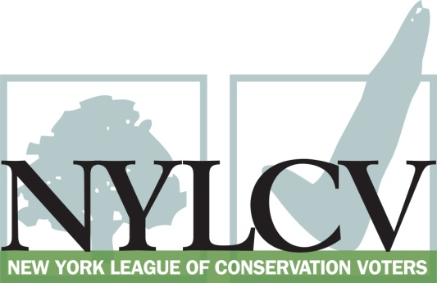

30 Broad Street – 30th Floor
New York, NY 10004
212-361-6350
politics@nylcv.org / www.nylcv.org
2017 Environmental Candidate Questionnaire
for New York City Candidates
Thank you for taking the time to fill out the New York League of Conservation Voters Questionnaire.
The New York League of Conservation Voters is the only non-partisan statewide environmental organization in New York that fights for clean water, clean air, renewable energy and open space through political action. This questionnaire is designed to elicit your views regarding what environmental, public health, clean energy and transit and environmental justice groups consider to be the most important issues of the day. Responses may inform NYLCV’s educational and legislative programs and actions NYLCV takes in the election cycle.
Responses should be considered public. Although NYLCV may choose not to publicize responses to every question, verbatim responses may be reproduced and distributed publicly. If so, your responses may be shortened, if necessary, but will not be edited in substantive ways. If you choose to refer us to a position paper or website, please indicate exactly what text you would like us to cite. For candidates choosing not to respond to the questionnaire, NYLCV will note as much in its public materials.
NYLCV and its partners in the environmental policy arena believe that New York’s voters are determined to make the environment a voting issue this year. Candidate positions on issues such as protecting public health, building a clean energy future, and mitigating climate change will help voters decide how to cast their ballots this election cycle. This questionnaire is one of the primary ways the public will get this information.
Here are a few guidelines:
- Questionnaires are due Friday, May 19
  - The completed questionnaire is mandatory for endorsement consideration and must be submitted via e-mail as a Microsoft Word file to: politics@nylcv.org
  - Questions or extension requests may be directed to Joshua Klainberg (jklainberg@nylcv.org)
- To ensure your responses address the issues NYLCV and its partners are most concerned about, please review NYLCV’s 2014-18 NYC Policy Agenda
- After receipt of the completed questionnaire, candidates will be invited to participate in a formal interview with our Chapter Board
- All candidate endorsements will be made by the state board on July 26, 2017
Campaign Contact Information
Candidate Name:
Office Sought (district if applicable):
E-mail:
Mailing Address:
Phone:
Website:
Facebook Page:
Twitter handle:
Campaign Manager’s name and email:
Press Secretary’s name and email:
Scheduler’s name and email:
PERSONAL INFORMATION
- Please share your accomplishments or experiences that indicate your commitment to advancing a pro-environment agenda. These experiences may be professional or personal.

ISSUES
Please indicate your level of commitment to, and if applicable your recent personal and professional activity with respect to, the following issues:

(To ensure your responses address the issues NYLCV and its partners are most concerned about, please review NYLCV’s 2014-18 NYC Policy Agenda when formulating your responses.)
Healthy New Yorkers: Policies that improve the well-being of all New Yorkers through the protection of the environment and that provide access to basic needs.
- Water Quality — Every New Yorker has the right to clean drinking water and waterways

- Air Quality – Every New Yorker has the right to breathe clean air

- Healthy & Local Food – Every New Yorker has the right to access healthy, local, affordable produce

- Green Buildings – Every New Yorker deserves the protection of a home that is energy efficient and is resilient to impacts of storms heat waves and extended utility outages

Strong Neighborhoods: Promote policies that improve the quality of life for communities in all five boroughs.

- Parks & Recreation – Every New Yorker should live within a 10-minute walk of a park that is clean, safe and well-maintained

- Waterfront Access – Every New Yorker should have safe and public access to clean rivers, creeks, bays, harbors and other waterways

- Transportation – Every New Yorker should have safe, affordable, reliable and efficient transportation options in their daily life

- Resiliency & Recovery – All communities should be better able to handle extreme weather events: rainfall, snow, storm surges, heavy wind, heat and utility failures

Vibrant Economy: Promote policies that foster green job creation while protecting New Yorkers from the effects of climate change

- Infrastructure – Make critical investments to maintain New York City’s competitive edge in the global economy while creating local jobs

- Solid Waste – Effective solid waste management will reduce environmental burdens in overburdened communities, save the city millions of dollars in exporting waste and generate quality green jobs

- Green Workforce Development – Provide training for New Yorkers to help green the city and support its resiliency

