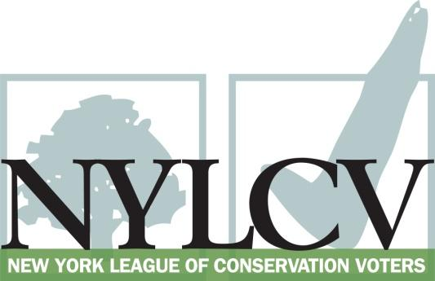

30 Broad Street – 30th Floor
New York, NY 10004
212-361-6350
politics@nylcv.org
www.nylcv.org
2016 Environmental Candidate Questionnaire
Campaign Contact Information
Candidate Name: Sara Niccoli
Office Sought (district if applicable): NYS Senate District 46
Website: http://saraniccoli.com/
Facebook Page: https://www.facebook.com/sarakingniccoli/
Twitter handle: @saraniccoli
- Please share you accomplishments or experiences that indicate your commitment to advancing a pro-environment agenda. These experiences may be professional or personal.
I have participated in the environmental justice movement my entire life and have attended rallies and signed petitions to stop the pipeline, end fracking, promote transportation alternatives, and lift up green energy.
I strongly believe that government incentive/regulation/enforcement is necessary to achieve the level of environmental protection that will save our planet, but my family also practices our beliefs.
I operate a family farm that uses organic growing methods (although we are not organic-certified) with more stringent environmental approaches than any organic or regulatory policy requires. For instance, although copper fungicide is considered organic, it is highly toxic to surrounding streams and wetlands. Therefore, we do not use it. We care deeply about our land and that means protecting it for future generations of farmers. We are also concerned about the rights of small growers globally to produce and save their own seed. GMO and F1 hybrid seeds can taint seed carefully selected over generations for specific regions and growing conditions. We us non-GMO, heirloom, and open-pollinated seed in our growing practice with very rare F1 hybrid where no strong open-pollinated option exists.
Everything feeds something else here on the farm and we make just a tiny amount of waste.
Our home is heated by just one small woodstove thanks to small, simple living, lots of insulation and south-facing windows.

Please indicate your level of commitment to, and if applicable your recent personal and professional activity with respect to, the following issues:

(To ensure your responses address the issues NYLCV and its partners are most concerned about, please review NYLCV’s 2016 State Policy Agenda)

- Ensuring adequate funding for the environmental agencies and programs
I am strongly committed to growing funding for environmental agencies and programs, including the Environmental Protection Fund, clean water infrastructure, the Department of Environmental Conservation, the Office of Parks, Recreation and Historic Preservation, and dedicated mass transit.

- Addressing the causes and effects of climate change (e.g., clean energy and emission controls)
I strongly support the 2030 state targets to reach 23% reduction in energy consumption for energy efficiency, 50% generation of renewable energy, and a 40% reduction in greenhouse gas emissions and will advocate tirelessly for the funding and projects necessary to achieve these goals.

- Protecting the health of New Yorkers and their communities (e.g., toxics, air quality, food quality and security)
I support comprehensive legislation to protect the community from toxic chemicals in toys, consumer products, hazardous waste, and pesticides. I will work to improve air quality through legislation that will reduce diesel emissions and encourage the use of ultra-low sulfur to replace #4 and #6 home heating oil and sustainable biofuel blends in home heating, commercial buildings and vehicles, particularly in areas with high rates of childhood asthma. I will fight for the protection of New York’s farmland through land conservation and sustainable agricultural program and I will advocate programs that connect agricultural products to consumers.

- Conserving and protecting natural resources (e.g., water, open spaces, habitat, organic recycling)
I will prioritize protection of New York’s natural resources including our parks, forests, lakes, rivers and oceans. This includes preservation of parkland, promoting regional ecosystems programs, incentivizing habitat management on private land, creating a wildlife habitat tax credit, addressing invasive species, protecting against inequitable land swaps, and diverting organic waste from landfills. I will advocate for continued investment in waste water and storm water treatment programs and full enforcement of the Sewage Pollution Right to Know Law.

- Investing in better, smarter infrastructure (e.g., transportation, electrical grid, green infrastructure, smart growth, rail transport of crude oil)
I will advocate transportation alternatives including multimodal mass transit, plug-in electric and ridesharing. I am committed to investment in green energy infrastructure. With a degree in Urban Planning, I am especially committed to smart growth models that prioritize sustainability and community walkability and vibrancy.

