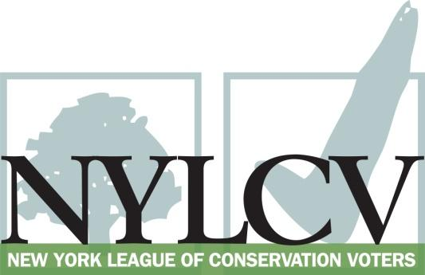

30 Broad Street – 30th Floor
New York, NY 10004
212-361-6350
politics@nylcv.org
www.nylcv.org
2016 Environmental Candidate Questionnaire
Campaign Contact Information
Candidate Name: Elaine Phillips
Office Sought (district if applicable): State Senator, 7th District
Website: www.elainephillips.org
Facebook Page: facebook.com/Elaine-Phillips-for-State-Senate
Please share your accomplishments or experiences that indicate your commitment to advancing a pro-environment agenda. These experiences may be professional or personal.
Throughout my career in the private sector and in public service, I have been motivated by a deeply held belief in her obligation to create a future that is better than the present. As a Long Islander, I am especially sensitive to the need to protect our precious shorefront, the LI Sound and drinking water quality. By taking steps now, we can protect these resources and their natural beauty for the use and enjoyment of future generations.
Superstorm Sandy was an especially urgent reminder to every Long Islander of the need for action. As the Mayor of a small village, I witnessed firsthand the unprecedented devastation caused by the storm, and heard firsthand accounts of the need to find ways to protect against such events in the future, and I am acutely interested in ways large and small that we can work at every level of government to protect our environment.
My village has long shown heightened awareness of water quality and protection issues. We are one of the few Long Island villages that filters storm water runoff to prevent contaminants from reaching surface waters and the sole source drinking water aquifer, a program that I have continued to support as Mayor through the village’s annual budget.
I’m especially proud of my post-Sandy initiative that has planted hundreds of trees in village right-of-ways to prevent soil erosion, protect groundwater, clean the air and provide cooling shade to reduce energy use. The program won national recognition and earned the village the designation, “Tree City USA” from the National Arbor Day Foundation. To protect our “suburban forest,” we’ve also embraced rules to protect old growth trees and, under my leadership, adopted regulations to prevent soil erosion around new residential construction sites.
I was actively involved in efforts to stop NYC DEP’s plan to tap into Long Island’s aquifer, which would only accelerate saltwater incursion and migration of potentially dangerous contaminants throughout the region’s public water supply.
Because we live so close to the Sound, and because of the lessons learned from Sandy, I’m concerned about coastal resiliency to prevent future storm damage. I’ve championed restoration of funding for testing and prevention of salt water intrusion into our drinking water supply and aquifer. Without these funds, we risk the spread of underground salt contamination into public water supplies that serve millions of Long Islanders. My community is actively involved with the Hempstead Harbor Protection Committee and the Port Washington/Manhasset Peninsula Aquifer Committee and support their work to protect the precious water resources that benefit and impact the entire region.
To promote cleaner air and better health, we joined with other local communities to construct a pedestrian trail connecting downtown to a close by LIRR station, to encourage commuters to walk or bike to mass transit rather than driving. I supported improvements to our village playground and recognize the need to protect and preserve more open space for the enjoyment of our communities.
My concern for the future of our environment is not just professional; it’s personal, too, and recognizing our own responsibility to future generations, my family installed a geothermal energy system in our home to reduce our reliance on non-renewable fuels.
As Senator, I will continue to be active in efforts to protect and safeguard our precious water resources and seek ways to improve the environment all across our region and state.

Please indicate your level of commitment to, and if applicable your recent personal and professional activity with respect to, the following issues:

(To ensure your responses address the issues NYLCV and its partners are most concerned about, please review NYLCV’s 2016 State Policy Agenda)

- Ensuring adequate funding for the environmental agencies and programs
I was thrilled to see the Governor and Legislature increase funding for the Environmental Protection Fund to coincide with the EPF’s 20th anniversary. The EPF provides vital capital for essential projects that conserve sensitive lands, support habitat restoration, wastewater, stormwater and pollution remediation, among others. A Senator, I will fight to fully fund the EPF and support increased spending for environmental remediation.

- Addressing the causes and effects of climate change (e.g., clean energy and emission controls)
I support the goals of the Governor’s clean energy initiative and believe that NY should be a leader in promoting clean energy to conserve resources and clean the air. As Mayor, I have been strongly focused on issues related to storm resiliency, including my village’s Tree City initiative, among others.

- Protecting the health of New Yorkers and their communities (e.g., toxics, air quality, food quality and security)
Protecting the environment is about much more than our future. A cleaner environment also promotes better health and quality of life for people living in our communities today. As a mother, I am very much concerned about the quality and safety of our food supply, and support use of the EPF for farmland preservation.
- Conserving and protecting natural resources (e.g., water, open spaces, habitat, organic recycling)
Earlier generations of New Yorkers were visionaries who preserved open spaces, and created public parks and one of the nation’s largest expanses of “forever wild” forests. We need to honor that vision by investing in more and better parks and open space, as well as resilient waterfronts, bays, oceans and lakes that support an expanding diversity of wildlife and recreational opportunities.

- Investing in better, smarter infrastructure (e.g., transportation, electrical grid, green infrastructure, smart growth, rail transport of crude oil)
I support the goals of the Governor’s clean energy initiative to expand the use of renewables and decrease our dependence on polluting fossil fuels, and support adequate funding for mass transit.

