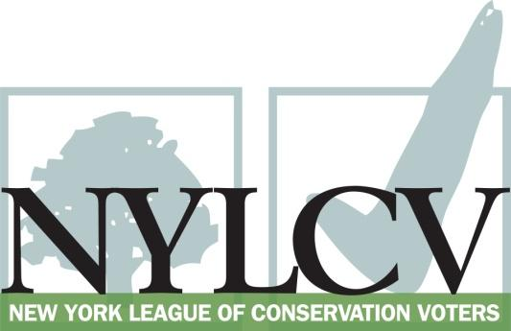

30 Broad Street – 30th Floor
New York, NY 10004
212-361-6350
politics@nylcv.org
www.nylcv.org
2016 Environmental Candidate Questionnaire
Campaign Contact Information
Candidate Name: Daniel G. Stec
Office Sought (district if applicable): NYS Assembly 114AD
Facebook Page: Assemblyman Dan Stec
Twitter handle: @danstec
- Please share you accomplishments or experiences that indicate your commitment to advancing a pro-environment agenda. These experiences may be professional or personal.
Prior to my election to the Assembly in 2012, I served as Queensbury Town Supervisor and Chairman of the Warren County Board of Supervisors. In these capacities I was a champion for the first local aquatic invasive species laws as well as providing local Town and County resources – funding and in-kind services – to combat invasive species. I also was a champion of the Westbrook project on Lake George, established two local lakes’ management districts and promoted town planning and zoning laws that protected our environment while achieving balance with other factors.
Personally, I am an avid hiker and the only Adirondack Forty-sixer serving ion the Legislature. I am a member of the Forty-sixers Board of Directors and a member of the Adirondack Mountain Club.
In the Assembly, I serve as the Ranker on the Environmental Conservation Committee where I have supported the recent increases to the EPF and where I maintain a close working relationship with NYSDEC, Committee Chair Steve Englebright and the numerous environmental groups associated with the Lake George Region and the Adirondacks.

Please indicate your level of commitment to, and if applicable your recent personal and professional activity with respect to, the following issues:

(To ensure your responses address the issues NYLCV and its partners are most concerned about, please review NYLCV’s 2016 State Policy Agenda)

- Ensuring adequate funding for the environmental agencies and programs
At each of the Environmental Conservation public hearings held in Albany in workup to the state budget I have questioned the DEC Commissioner as to whether he felt his department was adequately funded as I am concerned that they have been overtasked and not adequately staffed or funded. I have also openly supported the recent EPF increases. This year I voted in favor of the budget bill A9004 that increased the EPF to $300M. This year’s budget also increased DEC’s funding 13% and in support of that I voted in favor of budget bills A9000 and A9003 as well. I’ve also supported the state’s need to improve mass transit capital needs and I have been a strong supporter of increased CHIPS funding.

- Addressing the causes and effects of climate change (e.g., clean energy and emission controls)
Since I’ve been a member of the Assembly there have been a few bills voted on that support additional study and/or action to address climate change concerns. While certainly the debate continues – sometimes very energetically – I support common sense measures to reduce the risks of climate change and encourage more efficient use and reuse of our resources. Some bills that have not been brought to the floor that I think address this and that I support include A524 (Kolb) that encourages green jobs development through tax credits, A3562 (Tedisco) that encourages the use of alternative fuels and A5073 (Lopez) that would remove state sales tax on bio-diesel products made in the state.

- Protecting the health of New Yorkers and their communities (e.g., toxics, air quality, food quality and security)
As I stated in question 3 above – I support measures that would encourage the use of alternative fuels that would be cleaner. A more diversified energy approach that reduces the reliant on traditional fuels would go a long way toward improving air quality. I have also supported bills that support our state’s farmer in part because I believe more locally produced food is not only good for our economy but also is of higher quality and safer as it is produced closer to the end user.

- Conserving and protecting natural resources (e.g., water, open spaces, habitat, organic recycling)
The son of a retired NYS Forrest Ranger, I grew up with respect for protecting our lands and water as they play a vital role not only for our health but for that of our wildlife. Habitat conservation is critical and I have supported land use practices that respect this. At the local government level and in the Assembly, I have supported many land purchases in the Adirondacks over the years that strike a good balance between responsible recreational use and the protection of the Adirondacks.

- Investing in better, smarter infrastructure (e.g., transportation, electrical grid, green infrastructure, smart growth, rail transport of crude oil)
Infrastructure is something I have been particularly passionate about. Good infrastructure improvements are good for the economy, public safety and the environment. I support bills like A527 (Kolb) that would make it simpler for power companies to improve their transmission lines, as well as A1345 that creates a Flood Mitigation and Prevention Task Force.

