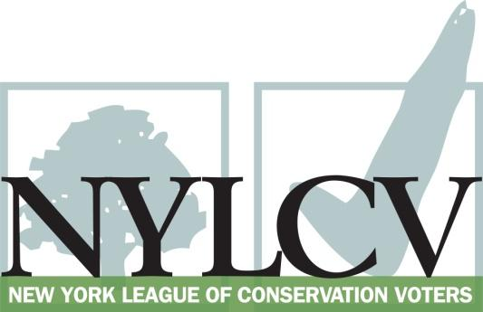

30 Broad Street – 30th Floor
New York, NY 10004
212-361-6350
politics@nylcv.org
www.nylcv.org
2016 Environmental Candidate Questionnaire
Campaign Contact Information
Candidate Name: Thomas J. Abinanti
Office Sought (district if applicable): Member of New York State Assembly, 92 AD
Website: Abinanti.com
Facebook Pages: Assemblyman Tom Abinanti and Tom Abinanti for State Assembly
Twitter handle: @TomAbinanti and @Abinanti2016
- Please share your accomplishments or experiences that indicate your commitment to advancing a pro-environment agenda. These experiences may be professional or personal.
Preserving our environment has been one of my prime concerns as an Assemblymember and, before that, as a County Legislator and Town Councilman. As a member of the Assembly Environment committee, I have actively promoted environment-friendly legislation and policies. I have sponsored/co-sponsored/voted for legislation to ensure adequate funding for the environment, address the causes and effects of climate change, protect the health of New Yorkers and their communities, protect natural resources and invest in better, smarter infrastructure. I sponsored/co-sponsored/voted to measures to foster clean water projects, prevent fracking in NY, ban idling of motor vehicles statewide (as I did in Westchester), promote cleaner fuels, set clean air targets, etc. I publicly opposed the Governor’s plan to raid environmental funds dedicated for clean water projects in order to finance the Tappan Zee Bridge construction ( rejected by the EPA).

Please indicate your level of commitment to, and if applicable your recent personal and professional activity with respect to, the following issues:

(To ensure your responses address the issues NYLCV and its partners are most concerned about, please review NYLCV’s 2016 State Policy Agenda)

- Ensuring adequate funding for the environmental agencies and programs
I am fully committed to adequate funding for the environmental agencies and programs. I advocated for and voted for funding the Environmental Protection Fund at $300 million in the 2016-17 state budget to address significant environmental, land protection, infrastructure and conservation needs in urban areas and throughout the state.

- Addressing the causes and effects of climate change (e.g., clean energy and emission controls)
I am fully committed to addressing the causes and effects of climate change. I have supported/sponsored/co-sponsored/voted for various measures to set goals and standards for Westchester and New York State including The Climate and Community Protection Act (A10342) designed to combat climate change in New York.
- Protecting the health of New Yorkers and their communities (e.g., toxics, air quality, food quality and security)
I am fully committed to Protecting the health of New Yorkers and their communities. As a member of the Assembly Environment committee, I participated in the Committee’s December 2011 hearing on the regulation of chemicals in children's products. I have co- sponsored and voted for various legislation passed in the Assembly to regulate their use in children’s products. I sponsor legislation to ban automobile idling for more than 3 minutes similar to what I passed as a Westchester County legislator. I passed legislation to reduce diesel emissions and have opposed the continual delay in the implementation of similar state regulations.
- Conserving and protecting natural resources (e.g., water, open spaces, habitat, organic recycling)
I am fully committed to conserving and protecting our natural resources. As a County Legislator, I led several successful efforts to preserve 100’s of acres of environmentaIly sensitive land and passed numerous laws to eliminate phosphates from fertilizers, detect contamination of underground water sources, improve sewage disposal facilities, foster/require recycling, etc. As an Assembly member, I advocated and for voted numerous similar measures.
- Investing in better, smarter infrastructure (e.g., transportation, electrical grid, green infrastructure, smart growth, rail transport of crude oil)
I am fully committed to investing in better, smarter infrastructure throughout the state. I have urged such funding in the budget and have signed on to various bills to accomplish this goal. I voted to support several million dollars in annual state spending on clean water infrastructure projects. I support fully funding the state’s mass transit capital needs and am supporting an effort to fund the MTA with revenues from a rearrangement of fees on motor vehicles entering and traveling in Manhattan.

