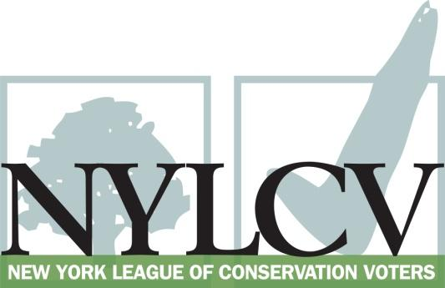

30 Broad Street – 30th Floor
New York, NY 10004
212-361-6350
politics@nylcv.org
www.nylcv.org
2016 Environmental Candidate Questionnaire
Campaign Contact Information
Candidate Name: Steve Otis
Office Sought (district if applicable): 91st Assembly District
Website: campaign www.steveotisassembly.com
Facebook Page: steveotisassembly
- Please share your accomplishments or experiences that indicate your commitment to advancing a pro-environment agenda. These experiences may be professional or personal.
My most recent accomplishment was my role in creating the Water Infrastructure Improvement Act of 2015. This new grant program now will provide $425 million in new environmental funding for municipal grants to support clean water infrastructure projects. This is a significant new program, especially given that it is new environmental funding outside and addition to EPF, which had a large increase this year as well.
I am involved in a wide variety of environmental and conservation issues in the Assembly. I currently serve on the Assembly Environmental Conservation Committee, the committee with jurisdiction over state parks, on the Assembly Climate Change Work Group, and as Chair of the Legislative Commission on Solid Waste Management. I also serve of the Committee on Corporations, Commissions and Authorities, which works on legislation relating to the PSC, MTA and other transportation authorities. In March I received Audubon New York’s William Hoyt Environmental Excellence Award.

I have played a leadership role of environmental issues for decades. As Mayor of the City of Rye (1998-2009) I implemented numerous environmental projects and initiatives, including four open space acquisitions, wetland protection, park improvements and other policies to enhance the environment.
As Counsel and Chief of Staff to State Senator Suzi Oppenheimer for over 25 years I worked on numerous statewide and local environmental issues.
My environmental activities include serving as past Chair of the City of Rye Conservation Commission and on the Board of Directors of the NYS Association of Conservation Commissions. I also served on the Westchester County Flood Action Task Force, as Vice Chair of the Long Island Sound Watershed Intermunicipal Council, Vice Chair of the Westchester County Environmental Management Council, and Co-Chair of the City of Rye’s Project Impact FEMA program. I have served on the Stewardship Committee of AudubonNY since 2009. In Rye I helped write Rye’s local wetlands law and wireless equipment siting law. I began on the Rye Recycling Committee and the Rye Conservation Committee in the late 1980’s.

Please indicate your level of commitment to, and if applicable your recent personal and professional activity with respect to, the following issues:

(To ensure your responses address the issues NYLCV and its partners are most concerned about, please review NYLCV’s 2016 State Policy Agenda)

- Ensuring adequate funding for the environmental agencies and programs
I strongly support increased environmental funding. In developing the concept for the clean water grant program mentioned above I understood the scope of the problem of municipalities being unable to pay for needed water quality projects was enormous. For that reason, Assemblyman John McDonald, another former Mayor, and I chose to propose a new program rather adding a funding line to the Environmental Protection Fund. Speaker Heastie, Governor Cuomo and the Senate supported this approach and included $200 million in the 2015-16 budget to cover the first three years of the program (2015-2017). The demand for funding was so large that Governor Cuomo added an additional $25 million to the 2015 round using available federal funds. In 2016 the Governor proposed an additional $100 million and a second $100 was added through the budget negotiations. In making the case for a separate program we have been able to see strong growth in EPF this year complimenting the additional $425 for water grants. The Cuomo Administration and the Environmental Facilities Corporation have done an excellent job in implementing the program and working with municipalities to encourage and make affordable clean water projects that were not going forward before the water grant program was created.

- Addressing the causes and effects of climate change (e.g., clean energy and emission controls)
I support the aggressive pace at addressing climate change policies that NYS has adopted and support those policies through the state budget and legislative proposals. This year Assembly changes to the budget to enhance climate change polices were supported by the Governor and the Senate in the adopted budget. NYSERDA, DEC and the PSC have all played positive roles in moving programs and policies forward on climate change issues. I cosponsor A10342, the New York State climate and community protection act which has been introduced.
I was also a co-sponsor and active supporter of the climate change legislation signed into law in 2014 which requires consideration of climate change and sea level rise issues in government decisions. The law applies the same smart growth approach to decisions that would be affected by climate change.
- Protecting the health of New Yorkers and their communities (e.g., toxics, air quality, food quality and security)
I have been active and supportive of these issues in a variety of ways including my concern about the siting of facilities in residential areas, environmental justice issues, opposition to hydro-fracking and support for clean water and clean air issues. I sponsor food safety legislation to improve food-handling practices by individuals who prepare food. (A. 10216 Requires that sanitary gloves be changed after performing certain tasks.)

- Conserving and protecting natural resources (e.g., water, open spaces, habitat, organic recycling)
I have worked on all of these issues for many years. As Chair of the Legislative Commission on Solid Waste Management, we are looking at the opportunity to expand food waste and organic recycling in school district food service programs. I have long been an advocate for open space acquisition programs, habitat protection, wetland preservation and Long Island Sound.

- Investing in better, smarter infrastructure (e.g., transportation, electrical grid, green infrastructure, smart growth, rail transport of crude oil)
I support mass transit, smart growth and intelligent transportation policies that consider the many benefits of good planning for air quality and reducing reliance on fossil fuels. I co-sponsor legislation to increase liability and protection for the rail transport of crude oil. (A07625, passed Assembly in 2015 and 2016).

