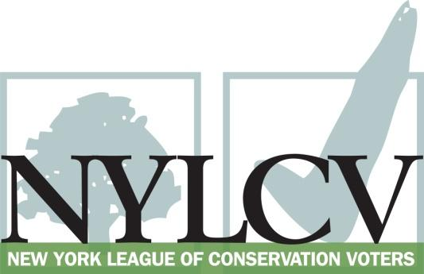

30 Broad Street – 30th Floor
New York, NY 10004
212-361-6350
politics@nylcv.org
www.nylcv.org
2016 Environmental Candidate Questionnaire
Campaign Contact Information
Candidate Name: Shelley Mayer
Website: www.shelleymayerforassembly.com (campaign)
Facebook Page: https://www.facebook.com/ShelleyMayer90?ref=hl
Twitter handle: @shelleybmayer
- Please share your accomplishments or experiences that indicate your commitment to advancing a pro-environment agenda. These experiences may be professional or personal.
As an elected leader representing Yonkers in Albany, I have seen first hand the effects of climate change on our natural resources, neighborhoods, and our economy. We have experienced extensive and repeated flooding in Yonkers, and I have worked hard to secure resources for flood mitigation. With strong advocacy from me, Governor Cuomo allocated three million dollars in federal recovery funds to Yonkers’ resiliency projects. The process, in which I was very involved, was attentive to economic, homeowner, and environmental concerns. In addition, I introduced legislation (A1345/S4940) that would provide for coordination and comprehensive approach to flood mitigation. This bill passed both the Assembly and the Senate. Although it was vetoed by the Governor, his appropriation of money for climate change begins to move us in the right direction. I have signed onto legislation that will increase public protections from exposure to radon in natural gas (A778). Early in my first term, I toured regions in Pennsylvania to see first hand the effects of natural gas fracking, and I have supported the ban on it. In the community, I have supported efforts to maintain green spaces, expand public transit, and bike access and have worked with constituents to reduce use of herbicides and pesticides on state roads.

Please indicate your level of commitment to, and if applicable your recent personal and professional activity with respect to, the following issues:

(To ensure your responses address the issues NYLCV and its partners are most concerned about, please review NYLCV’s 2016 State Policy Agenda)
- Ensuring adequate funding for the environmental agencies and programs
I supported and am please with the 2016-17 New York State budget provision of $300 million for the Environmental Protection Fund (EPF), $36 million for municipal parks and waterfront revitalization, and a continued investment in clean water infrastructure. As a representative of Yonkers, I am particularly pleased that much of the parks and waterfront revitalization funding will go to low-income and urban communities. In addition, I am consistently vocal in my commitment to increasing funding for public transportation operating and infrastructure spending, and I am pleased this year’s budget builds on those investments.

- Addressing the causes and effects of climate change (e.g., clean energy and emission controls)
As a representative of Yonkers, I see the causes and effects of climate change. Lack of investment in public transportation infrastructure and operating makes public transportation undesirable and difficult to use, yielding high levels of pollution and asthma, particularly within low-income urban communities. I also see the effects of climate change on persistent flooding. I support short and low-term efforts to address these problems, efforts to create reliable funding for public transportation, investment in clean renewable energy and emissions controls.
- Protecting the health of New Yorkers and their communities (e.g., toxics, air quality, food quality and security)
Throughout my career in and out of public office, I have been an advocate for consumer and environmental protections. The Assembly, with my support, has repeatedly passed The Child Safe Products Act. I have long recognized the health and economic costs of air pollution, especially in low-income communities. I have supported efforts to reduce emissions and protect food, air and water. Most recently, I have worked with a constituent to explore ways to reduce the use of pesticides and herbicides on NYS roadways. I am a co-sponsor of Assemblywoman Lupardo’s bill A. 9687 to require periodic testing of water in schools. This is a serious problem which requires a strong state response. I also co-sponsor A9230 the Triclosan Awareness Act and A130 which bans frack water from landfills.

- Conserving and protecting natural resources (e.g., water, open spaces, habitat, organic recycling)
I have supported investment in protecting our natural resources and preserving our open spaces. I have worked with community groups to invest and preserve open spaces, and have provided funding for community groups working to preserve parks and trails. As an advocate and elected leader, I have worked to ensure the process and use of parkland alienation is transparent and consistent with the spirit of the law and protects communities’ access to open space and parks.
- Investing in better, smarter infrastructure (e.g., transportation, electrical grid, green infrastructure, smart growth, rail transport of crude oil)
Since I was elected in 2012, I have been a strong advocate for investing in our infrastructure and public transit. I have supported these investments as a priority for job growth and economic opportunity, as well as to eliminate emissions and address climate change. This year, the enacted budget includes one of my top priorities – increased investment in operating aid for Westchester County transit services, such as the Bee-Line bus. I have worked closely with local, regional and statewide advocates to increase investment in smart growth and comprehensive transportation alternatives. In addition, since Hurricane Sandy underscored the inadequacy of our utility infrastructure and responsiveness, I have sponsored a bill, A1937A, that would require the Public Service Commission to establish and enforce compliance with power restoration performance standards for certain utility companies to reduce the duration of outages and disruptions and to ensure investment in our utilities.

