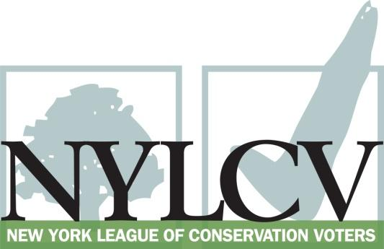

30 Broad Street – 30th Floor
New York, NY 10004
212-361-6350
politics@nylcv.org
www.nylcv.org
2016 Environmental Candidate Questionnaire
Campaign Contact Information
Candidate Name: Sean Ryan
Office Sought (district if applicable): 149th Assembly District
Website: seanryanassembly.com
Facebook Page: facebook.com/AssemblySeanRyan
Twitter handle: twitter.com/SeanMRyan149
- Please share your accomplishments or experiences that indicate your commitment to advancing a pro-environment agenda. These experiences may be professional or personal.
I continue to fight for modern and smart urban development. From the Scajaquada redesign to the Outer Harbor development, modernizing our community in an environmentally sound manner is of the utmost importance. I have been proud to lend my voice and to vote for legislation such as microbeads, brownfield extension, and increasing funding for water cleanup. The accomplishment I consider my personal favorite is helping to bring the bike ferry to the harbor. This has not only opened up the outer harbor and the wonderful sites that it contains, but does so in a way that does not increase motor vehicle use.

Please indicate your level of commitment to, and if applicable your recent personal and professional activity with respect to, the following issues:

(To ensure your responses address the issues NYLCV and its partners are most concerned about, please review NYLCV’s 2016 State Policy Agenda)

- Ensuring adequate funding for the environmental agencies and programs
I voted to increase funding during this last year’s budget and will continue to push for more funding.

- Addressing the causes and effects of climate change (e.g., clean energy and emission controls)
I’ve worked with the assembly leadership to address climate change. We have put rules in place to control green house gases. Personally, I sponsored the Geothermal Tax Credit bill which passed last year.
- Protecting the health of New Yorkers and their communities (e.g., toxics, air quality, food quality and security)
I understand the importance of maintaining healthy communities for all of our shared benefit. I have taken a strong interest in lead paint protection and support ongoing efforts to reduce the amount of lead poisoning in our community. Often it is the populations that are least able to protect themselves (children, people with disabilities) that suffer from our communities inadequate protection of our natural resources.
- Conserving and protecting natural resources (e.g., water, open spaces, habitat, organic recycling)
As my district runs a significant portion of my district runs along Lake Erie, I pay particular attention to the health of our natural resources. Woodlawn Beach water quality, banning microbeads and triclosan, cleaning up the Scajaquada Creek, and improving the air quality throughout the area are all issues I have pushed in the past two years.

- Investing in better, smarter infrastructure (e.g., transportation, electrical grid, green infrastructure, smart growth, rail transport of crude oil)
Smart growth and modern urban development are all important issues in my district. Highway redesign, Outer Harbor development, modernizing our electrical infrastructure to improve use and conservation of energy, and water and sewer infrastructure have all become important and pressing issues throughout my time in the assembly.

