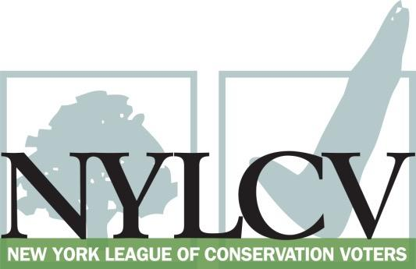

30 Broad Street – 30th Floor
New York, NY 10004
212-361-6350
politics@nylcv.org
www.nylcv.org
2016 Environmental Candidate Questionnaire
Campaign Contact Information
Candidate Name: Jose M Serrano
Office Sought (district if applicable): State Senate - 29th District
Facebook Page: /SenatorJoseMSerrano
Twitter handle: @SenatorSerrano
- Please share your accomplishments or experiences that indicate your commitment to advancing a pro-environment agenda. These experiences may be professional or personal.
I am a strong believer in the transformative effect of the great outdoors and nature. Our amazing parks, water ways, and green spaces provide tremendous recreational, health and wellness opportunities. But none of this is possible without a clean and healthy environment, and this is why I spend so much time as an elected official advocating for a clean and respected environment. My community in the South Bronx and East Harlem suffer from some of the worst health disparities anywhere, and there is a direct correlation with our environment. To reduce the instances of asthma and diabetes, we must ensure that our local environments are as clean as possible. For that I am very grateful to the NYLCV for their commitment and advocacy on these important issues. I am the sponsor of many pieces of legislation that will help create a cleaner and healthier New York, and I look forward to continuing this struggle.

Please indicate your level of commitment to, and if applicable your recent personal and professional activity with respect to, the following issues:

(To ensure your responses address the issues NYLCV and its partners are most concerned about, please review NYLCV’s 2016 State Policy Agenda)

- Ensuring adequate funding for the environmental agencies and programs
Very Committed.
- Addressing the causes and effects of climate change (e.g., clean energy and emission controls)
Very committed.
- Protecting the health of New Yorkers and their communities (e.g., toxics, air quality, food quality and security)
Very committed.
- Conserving and protecting natural resources (e.g., water, open spaces, habitat, organic recycling)
Very committed.
- Investing in better, smarter infrastructure (e.g., transportation, electrical grid, green infrastructure, smart growth, rail transport of crude oil)
Very committed.

