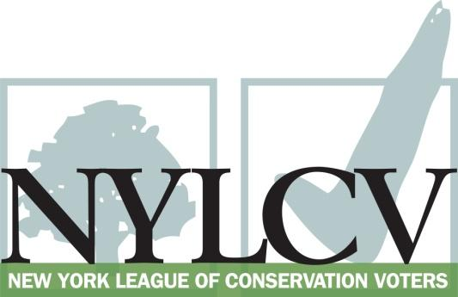

30 Broad Street – 30th Floor
New York, NY 10004
212-361-6350
politics@nylcv.org
www.nylcv.org
2016 Environmental Candidate Questionnaire
Campaign Contact Information
Candidate Name: Joseph Robach
Office Sought (district if applicable): State Senate, 56th District
Website: www.joerobach.com
Facebook Page: www.facebook.com/senatorjosepherobach
Twitter handle: @SenatorRobach
Please share your accomplishments or experiences that indicate your commitment to advancing a pro-environment agenda. These experiences may be professional or personal.
Throughout my time in the New York State Senate, I have taken very seriously the responsibility of protecting the environment of our state. As the Chairman of the Senate Transportation Committee, when pieces of legislation come before my committee, I closely consider their impact on our environment. Growing up, living along and representing the shore of Lake Ontario and the banks of the Genesee River, I have a great appreciation for the value of our environment and how imperative it is that legislators in Albany, such as myself, do what we can to protect it. That is why I have supported and advocated for measures that would dramatically increase funding to ensure safe water access and infrastructure, measures that would put more clean cars and vehicles on our roads and non-toxic toys in the hands of our children. As a member of the State Senate, there are many important issues that come before us on a daily basis, however there are few issues that have the impact on current and future generations as environmental protection measures do. I consider myself to be a friend of the environment and will continue to support measures that ensure the preservation of our environment for years to come.

Please indicate your level of commitment to, and if applicable your recent personal and professional activity with respect to, the following issues:

(To ensure your responses address the issues NYLCV and its partners are most concerned about, please review NYLCV’s 2016 State Policy Agenda)

Ensuring adequate funding for the environmental agencies and programs
The 2016-2017 budget included a record $300 million investment in the Environmental Protection Fund to ensure clean water and clean air. This was a nearly 70% increase over last years’ state commitment. This funding will help to ensure that communities across New York State are able to deal with any potential hazards in their public water supply. In addition, I was pleased to support a measure to include an additional $200 million over the next two years specifically for clean water infrastructure and water quality improvements for a total $350 million state commitment in this year’s budget. These funds will hopefully ensure that New Yorkers will need not worry about the integrity of their water when it comes out of the faucet or tap.

Addressing the causes and effects of climate change (e.g., clean energy and emission controls)
As Chairman of the Senate Transportation Committee, I was proud to support a measure included in this years’ budget to offer consumer rebates for the purchase of new electric vehicles. Buyers will be eligible for up to a $2,000 rebate for a battery-only electric vehicle, a plug-in hybrid, or a fuel-cell electronic car. By offering this incentive and increasing the number of electric cars on New York’s roads, it will help meet New York’s ambitious and scientifically-mandated climate goals of cutting economy wide greenhouse gas emissions by 40% by 2030 and 80% by 2050.
Protecting the health of New Yorkers and their communities (e.g., toxics, air quality, food quality and security)
I am a Co-Sponsor of S4102, legislation to prevent the use of dangerous chemicals and ensure the use of safer chemical alternatives in children's products. This measure protects consumers from toxic chemicals in children's products by defining what is toxic while also establishing a list of priority chemicals and chemicals of high concern to children. Currently, New York identifies or prohibits the use of dangerous chemicals on a chemical by chemical basis; this approach is especially problematic for children's products since children are often more vulnerable to smaller amounts of chemicals, and equally-toxic, less well-regulated chemicals can be chosen as replacements.
Throughout my career, I have supported New York State’s brownfield rehabilitation program. This program is imperative to the continued cleanup and redevelopment of contaminated sites across the state, including many successful projects in the Rochester area. These brownfield rehabilitation measures not only result in economic development but that the neighborhoods where these projects take place are healthier for the foreseeable future.
I also support and am a Co-Sponsor of S485B, legislation that would mandate the labeling for genetically engineered (GE) foods or genetically modified organisms (GMO). The bill would provide New York State consumers with the ability to make an informed choice when purchasing these food items.
Conserving and protecting natural resources (e.g., water, open spaces, habitat, organic recycling)
During my time in the State Senate, I have consistently sought to ensure that we leave an environment that is healthy and protected for future generations. By funding and supporting measures to preserve our parks and historic sites, both in my district and statewide, it is my hope that New Yorkers will be environmentally protected for year’s to come. By securing funding locally for our trail system, we are allowing greater access for residents to our parks and open spaces. I understand the importance of protecting and maintaining New York’s waterways, including Lake Ontario and the Genesee River.
Investing in better, smarter infrastructure (e.g., transportation, electrical grid, green infrastructure, smart growth, rail transport of crude oil)
I was proud to vote for and support S2693, a measure that would allow geothermal technology to receive funding under Public Authorities Law. Geothermal services are not only more efficient but are much healthier for the environment then standard methods of supplying heat to buildings. Allowing this funding in New York will increase the use of geothermal energy and systems, thus creating more green jobs and reducing the amount of carbon used to heat buildings.
As Senate Transportation Chairman, I am proud to support various measures for allowing greater access for bicycle riders across New York and have worked closely with them to make our state more bicycle friendly. Measures such as a three-foot passing law for bicyclists on public roads, dedicated bike paths and allowing for E-Bikes in New York, allowing greater access to energy efficient transportation options.

