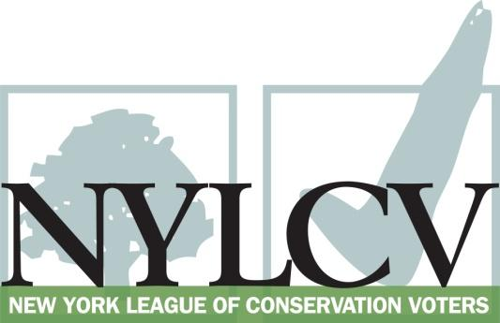

30 Broad Street – 30th Floor
New York, NY 10004
212-361-6350
politics@nylcv.org
www.nylcv.org
2016 Environmental Candidate Questionnaire
Campaign Contact Information
Candidate Name: Jeffrey D. Klein
Office Sought (district if applicable): State Senate, 34th District
Website: www.jeffkleinny.com
Facebook Page: www.facebook.com/jeffrey.d.klein
Twitter handle: JeffKleinNY
Please share your accomplishments or experiences that indicate your commitment to advancing a pro-environment agenda. These experiences may be professional or personal.
I have long fought to ensure that New York is prepared for future climate change and does all it can to mitigate its severity. After Superstorm Sandy, I co-sponsored legislation with Sen. Savino to require consideration of projected climate change impacts in all state and local permitting decisions. I have also worked to ensure that New York’s honors its commitments under the Regional Greenhouse Gas Initiative and the Diesel Emissions Reduction Act. I continue to support a statewide ban on hydrofracking and limitations on the import of dangerous waste products with the potential to corrupt our natural resources and watersheds. I have worked to keep New Yorkers healthy by protecting parklands, conserving green spaces and outdoor play spaces, and improving access to mass transit in my local community.

Please indicate your level of commitment to, and if applicable your recent personal and professional activity with respect to, the following issues:

(To ensure your responses address the issues NYLCV and its partners are most concerned about, please review NYLCV’s 2016 State Policy Agenda)

Ensuring adequate funding for the environmental agencies and programs
I successfully advocated for a State Budget that funded the Environmental Protection fund at the historic level of $300 million and increased funding for clean water infrastructure by $200 million. I also supported increased operating aid for transit system statewide capital investments in upstate transit to help build a more robust public transit system statewide.

Addressing the causes and effects of climate change (e.g., clean energy and emission controls)
This year I helped create a new $22 million Climate Mitigation Account within the Environmental Protection Fund. I also support greater public investment in clean energy and maintaining New York’s strong commitment to reduce emissions under the Regional Greenhouse Gas Initiative.
Protecting the health of New Yorkers and their communities (e.g., toxics, air quality, food quality and security)
I continue to co-sponsor and be a strong advocate for the Child Safe Products Act and am currently working to pass legislation that will help protect the security our vital water supply systems.
Conserving and protecting natural resources (e.g., water, open spaces, habitat, organic recycling)
I supported increased funding for the Open Space Program in the Environmental Protection Fund in this year’s budget, as well as greater funding to combat the threat of invasive species around the state. In addition I have committed funding to the Creation for the Hudson River Greenway in Riverdale and was a signatory of an amicus brief to prevent LG electronics from building a Tower in New Jersey which would have drastically ruined the landscape of the Palisades.
Investing in better, smarter infrastructure (e.g., transportation, electrical grid, green infrastructure, smart growth, rail transport of crude oil)
I have supported much-needed capital investments in the MTA and upstate transit, as well as funding for Zero Emissions Vehicles and infrastructure in the budget. I will continue to support these efforts, as well as a proposal by my conference to create a Smart Growth Fund to encourage localities to implement plans and methods to plan future development in an environmentally friendly manner.

