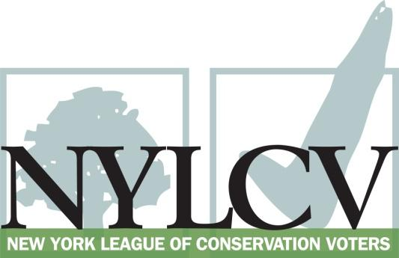

30 Broad Street – 30th Floor
New York, NY 10004
212-361-6350
politics@nylcv.org
www.nylcv.org
2016 Environmental Candidate Questionnaire
CAMPAIGN CONTACT INFORMATION
Candidate Name: Senator Bill Perkins
Office Sought (district if applicable): New York State Senate | District 30
Please share your accomplishments or experiences that indicate your commitment to advancing a pro-environment agenda. These experiences may be professional or personal.
I led the movement to eradicate lead paint from the City’s housing stock over a decade ago; I was one of the most outspoken opponents of hydrofracking in the State; I was proud to pass legislation in 2010 that limits the sulfur content in home heating oil; I held a public hearing on the status of Superfund sites in my district. I was proud to participate in the People’s Climate March. I have fought to keep and expand parks and community gardens in SD-30. It is my personal and representative philosophy that the earth and the environment are precious resources that we must protect; environmental rights are human rights because they directly impact our ability to breathe, drink, eat and live a normal life.

Please indicate your level of commitment to, and if applicable your recent personal and professional activity with respect to, the following issues:

(To ensure your responses address the issues NYLCV and its partners are most concerned about, please review NYLCV’s 2016 State Policy Agenda)

Ensuring adequate funding for the environmental agencies and programs
Every year in the State Senate I have supported increases in the EPF and for the DEC and related agencies, in particular in the areas of enforcement and environmental justice initiatives.

Addressing the causes and effects of climate change (e.g., clean energy and emission controls)
I am a proud and staunch supporter and co-sponsor of Senate Bill 8005, The "New York State Climate and Community Protection Act" to address and mitigate the impacts of climate change in New York. I adamantly vote against all bills that rely upon non-renewable sources of energy. I support a robust REV plan and modification of the RGGI to focus only on clean energy projects; I supported the People’s Climate March and all of the related goals of it.
Protecting the health of New Yorkers and their communities (e.g., toxics, air quality, food quality and security)
I am the original sponsor of the Child Safe Products Act and have fought for years to clean up and properly remediate Brownfield and Superfund sites in my Senate. In addition, building off of my tenure in the City Council, I have continued to advocate for the eradication of lead in our housing stock statewide. I also support GMO labeling and all initiatives that support organic, local farming and sourcing.
Conserving and protecting natural resources (e.g., water, open spaces, habitat, organic recycling)
I was a leading opponent of hyrdofracking and am proud of our collective work on that battle; I support cleaning the entire Hudson River all the way down to NYC. I opposed the proposed diversion of Clean Water State Revolving Fund dollars for the construction of the New NY Bridge.
Investing in better, smarter infrastructure (e.g., transportation, electrical grid, green infrastructure, smart growth, rail transport of crude oil)
I believe that we should always encourage mass transit in all that we do; in fact, I do not even own a car. In all development projects, we must always protect and enhance green spaces. The bomb trains that run through this state should immediately be stopped until a full security review and environmental impact study can be undertaken.

