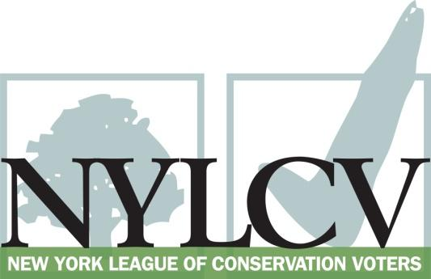

30 Broad Street – 30th Floor
New York, NY 10004
212-361-6350
politics@nylcv.org
www.nylcv.org
2016 Environmental Candidate Questionnaire
Campaign Contact Information
Candidate Name: Amy R. Paulin
Office Sought (district if applicable): State Assembly, 88th AD
Website: Amypaulin.com
Facebook Page: Amy Paulin
Twitter handle: @Amypaulin
Please share you accomplishments or experiences that indicate your commitment to advancing a pro-environment agenda. These experiences may be professional or personal.
Growing up in Brooklyn, NY I gained an early appreciation of the importance of open public green space for people of all ages – we all relied on public parks as a place to ride bicycles, have picnics and socialize with family and neighbors.
During my term as a trustee on the Scarsdale Village Board, I was chair of the land use committee that focused on controlled growth and preservation of open space in the Village. I also drafted a village law to preserve and protect wetlands in Scarsdale Village.
During my 16 year tenure in the State Assembly, I have consistently supported efforts to protect the environmental quality of our communities. For example, I have advocated for funds for environmental conservation and the EPF in extremely challenging budget environments, and supported efforts to address issues relating to climate change.
Since becoming Chair of the Assembly’s Energy Committee four years ago, my focus has been on creating incentives for and encouraging the residential and commercial use of alternative energy sources and decreasing green house gas emissions.

Please indicate your level of commitment to, and if applicable your recent personal and professional activity with respect to, the following issues:

(To ensure your responses address the issues NYLCV and its partners are most concerned about, please review NYLCV’s 2016 State Policy Agenda)

- Ensuring adequate funding for the environmental agencies and programs
I advocated for, and supported, full funding of the EPF during this year’s budget negotiations. As you know, the EPF provides monies to support a number of environmental initiatives. I also supported a $200 million increase to the Water Infrastructure Improvement Act to assist municipalities fund water quality infrastructure.
- Addressing the causes and effects of climate change (e.g., clean energy and emission controls)
Given that vehicle emissions are a major source of greenhouse gases, as chair of the Energy Committee I have sought to encourage the use of electric vehicles. I was instrumental in getting provisions in the budget to provide economic incentives to municipalities and consumers to invest in zero emission vehicles.
During my time as Chair of the Energy Committee, I have focused on encouraging the use of renewable energy. I authored legislation to allow shared renewable energy projects, so people who are unable to install solar or wind at their homes can share in a project and receive the benefits on their utility bills. This initiative was adopted by the Public Service Commission and the first projects are now underway.
I supported funding in the budget for climate change initiatives ($24 million) that includes funds for Climate Smart Communities Program and Climate Resilient Farms.
I wrote legislation that led to the adoption by the Public Service Commission of a pilot project in Westchester County, and recently a statewide program, for community choice aggregation. That program permits municipalities to use their bargaining power to negotiate with energy suppliers for meaningful savings in utility bills for their residents. In addition to cost savings, the program encourages participating municipalities to choose 100% green energy as the default option, greatly increasing the demand for renewable energy while reducing its cost to consumers.
I have supported A.6072, a bill to require the DEC to issue regulations relating to vehicle emissions that has passed the Assembly each year since 2008.
I recently held hearings on barriers to net energy metering for residential and commercial customers, focusing on interconnection requirements and standby rates.
On the local level, I am working with the NYLCV electric vehicle group to encourage development of charging stations and associated infrastructure in Westchester.
- Protecting the health of New Yorkers and their communities (e.g., toxics, air quality, food quality and security)
I am the sponsor of A.129 that would prohibit the application of pesticides at summer camps. It has passed the Assembly each year for the past four years.
I have long been a co-sponsor of A.5612a, legislation that would ban certain chemicals that are particularly toxic to children and that has passed the Assembly each year since 2010.
I have supported A.2592 with respect to lead poisoning that also continues to pass in the Assembly
I supported the effort to establish a permanent environmental justice group within the DEC and to designate high local environmental impact zones.
I am a co-sponsor of A.617 that would require companies to label foods containing GMO’s.
On the local level, I am working with constituents looking to bring municipal food composting to Westchester.
- Conserving and protecting natural resources (e.g., water, open spaces, habitat, organic recycling)
This year’s budget included funding for municipal and organic recycling, open space and farmland protection. It also provided monies for waterfront revitalization, water quality improvement projects, homeowner water testing and drug collection.
- Investing in better, smarter infrastructure (e.g., transportation, electrical grid, green infrastructure, smart growth, rail transport of crude oil)
I am a member of the task force that, in connection with the development of the new Tappan Zee bridge, has been advocating for rapid transit in Westchester County.
I am a co-sponsor of the Move NY (A.9633) legislation that has been expanded to include the Hudson Valley.
I have sponsored A.65, which would require local building and planning regulations to accommodate the use of alternative energy.
In this year’s budget, I successfully advocated for incentives for Zero Emission Vehicle infrastructure. Under this initiative, the Environmental Protection Fund (EPF) will provide municipalities with a rebate of up to $250,000 for such infrastructure creation.
I advocated to include discrete funds in the budget for public transportation and pedestrian and cycling infrastructure. The budget did include funding for transit systems, road and bridge repair, rail projects and airport revitalization.
I also support A.7625 to require major petroleum facilities to demonstrate financial responsibility and require railroads to submit certain financial preparedness information. It has passed the Assembly for the past two years.

